Irregular Zigzag Shapes
# Source: AI Source: Provided by: [Data Path: Persons Table -> ID Column: 1, Name_En Column: Motasem Essam] -> From: [ChatGPT] on [7/25/2026]
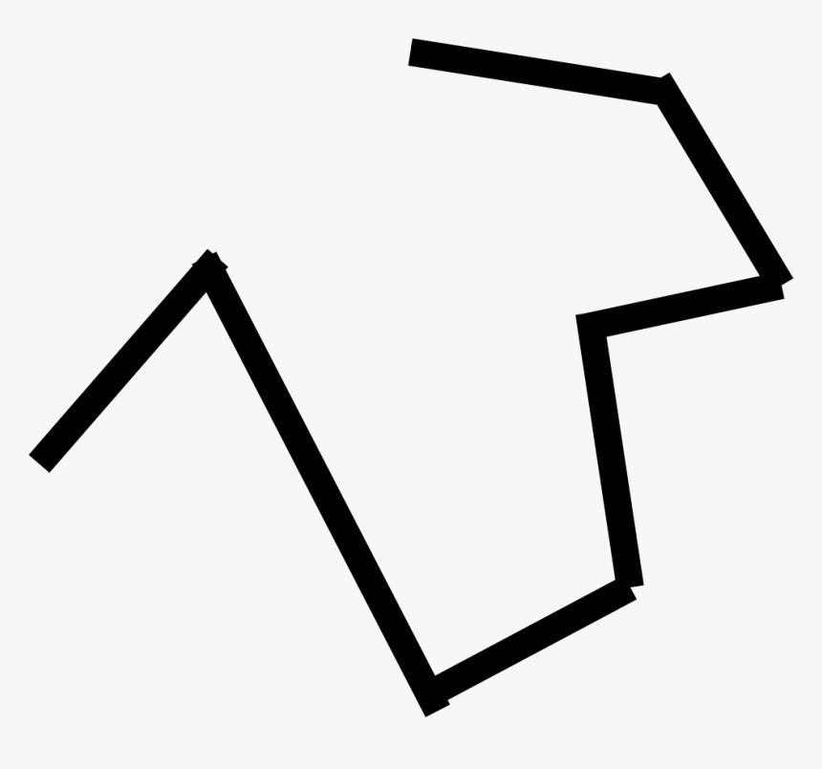
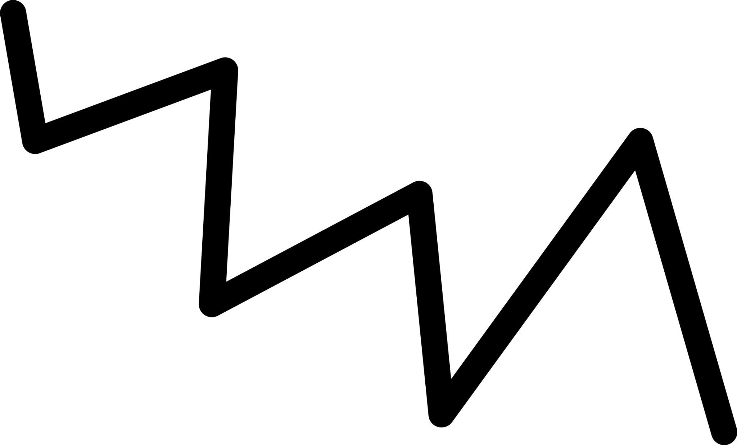
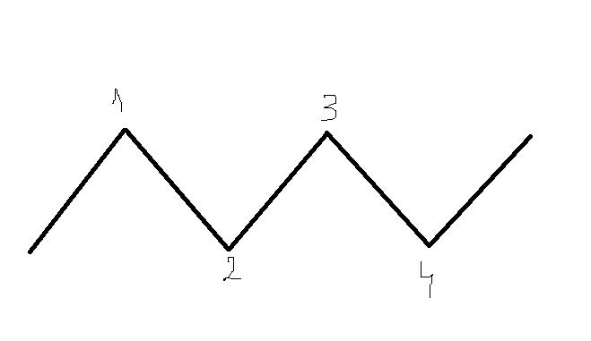
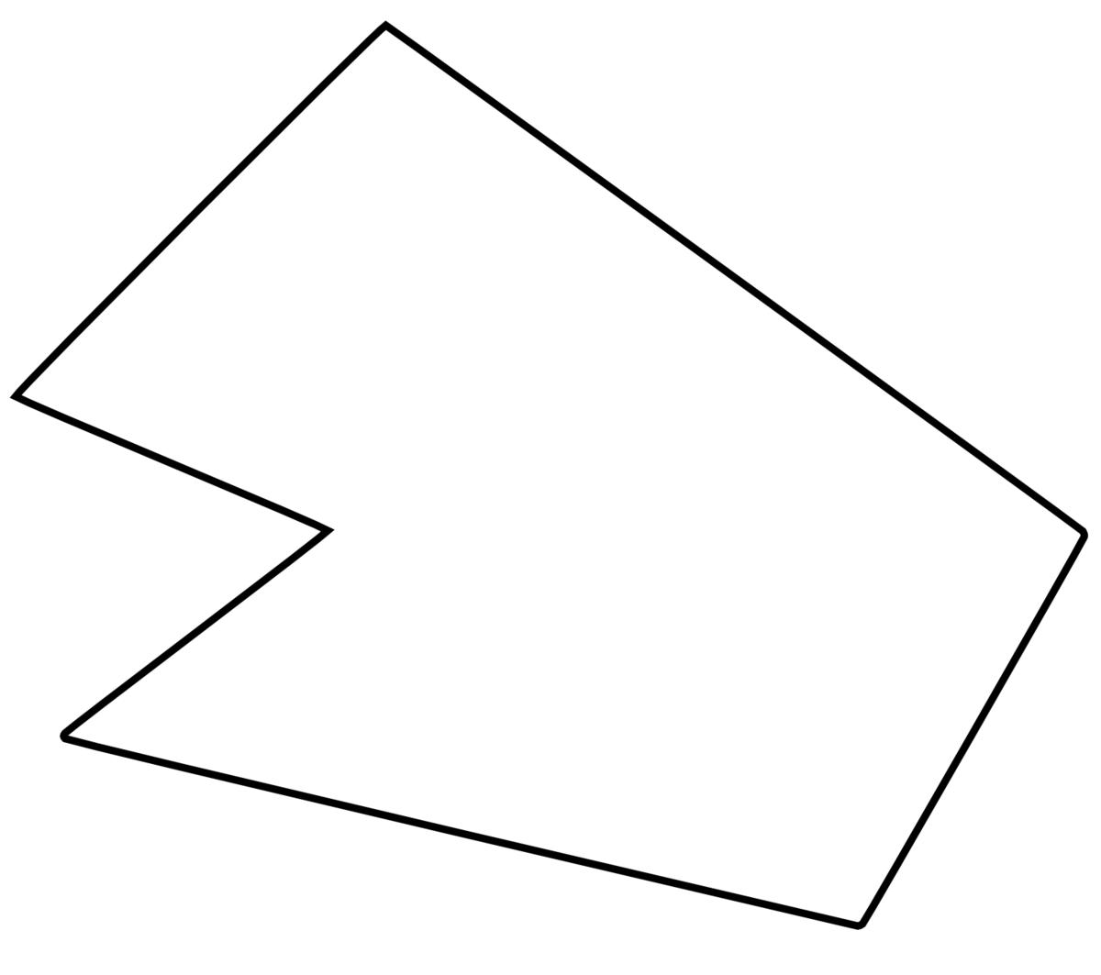
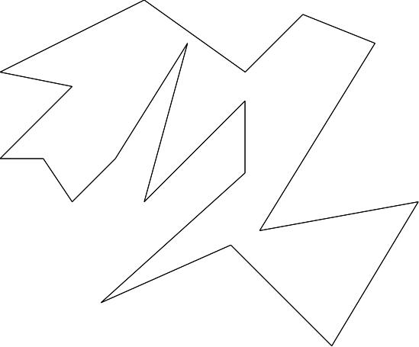

Definition
# Source: AI Source: Provided by: [Data Path: Persons Table -> ID Column: 1, Name_En Column: Motasem Essam] -> From: [ChatGPT] on [7/25/2026]
An Irregular Zigzag Shape is a zigzag shape whose segments, angles, lengths, or direction changes do not follow a consistent repeating geometric pattern.
Unlike a regular zigzag, an irregular zigzag may have different segment lengths, different angles, or varying zigzag depths.

Fundamental Concept
# Source: AI Source: Provided by: [Data Path: Persons Table -> ID Column: 1, Name_En Column: Motasem Essam] -> From: [ChatGPT] on [7/25/2026]
An irregular zigzag is formed by connecting straight-line segments while repeatedly changing direction, but without maintaining a uniform pattern.
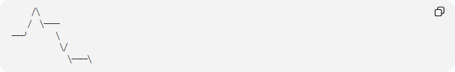
╱╲
╱ ╲────
───╯ ╲
╲╱
╲────╲
The segments and turns can vary throughout the shape.

Main Characteristics
# Source: AI Source: Provided by: [Data Path: Persons Table -> ID Column: 1, Name_En Column: Motasem Essam] -> From: [ChatGPT] on [7/25/2026]
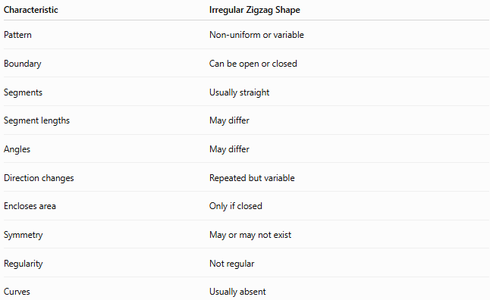
Characteristic | Irregular Zigzag Shape
Pattern | Non-uniform or variable
Boundary | Can be open or closed
Segments | Usually straight
Segment lengths | May differ
Angles | May differ
Direction changes | Repeated but variable
Encloses area | Only if closed
Symmetry | May or may not exist
Regularity | Not regular
Curves | Usually absent

Basic Structure
# Source: AI Source: Provided by: [Data Path: Persons Table -> ID Column: 1, Name_En Column: Motasem Essam] -> From: [ChatGPT] on [7/25/2026]
An irregular zigzag can be represented by:
$$P_{1}→P_{2}→P_{3}→⋯→P_{n}$$
where the lengths
$$l_{1},l_{2},l_{3},…,l_{n}$$
and turning angles may vary.
For example:
$$l_{1}≠l_{2}≠l_{3}$$
or:
$$θ_{1}≠θ_{2}≠θ_{3}$$
The exact inequalities are not required in every irregular zigzag; the essential idea is that the overall pattern is not uniformly repeated.

Types of Irregular Zigzag Shapes
# Source: AI Source: Provided by: [Data Path: Persons Table -> ID Column: 1, Name_En Column: Motasem Essam] -> From: [ChatGPT] on [7/25/2026]
Irregular zigzag shapes can be classified according to their boundary and geometric structure:
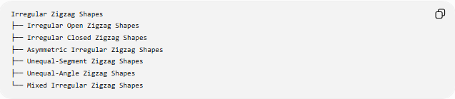
Irregular Zigzag Shapes
├── Irregular Open Zigzag Shapes
├── Irregular Closed Zigzag Shapes
├── Asymmetric Irregular Zigzag Shapes
├── Unequal-Segment Zigzag Shapes
├── Unequal-Angle Zigzag Shapes
└── Mixed Irregular Zigzag Shapes

1-Irregular Open Zigzag Shapes
# Source: AI Source: Provided by: [Data Path: Persons Table -> ID Column: 1, Name_En Column: Motasem Essam] -> From: [ChatGPT] on [7/25/2026]
An Irregular Open Zigzag Shape does not return to its starting point and has two endpoints.
╱╲────╲
╲╱╲──────
Its segment lengths or angles vary.
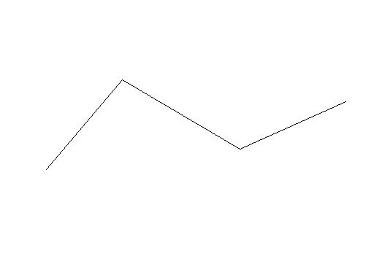
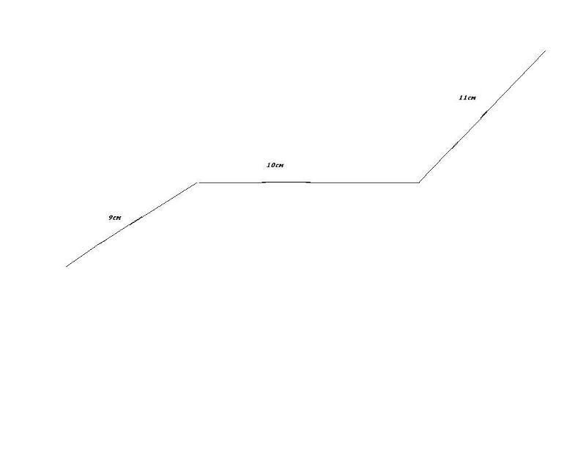
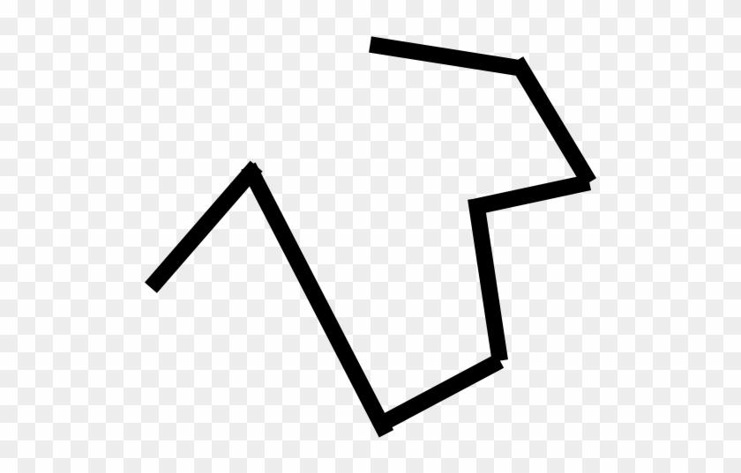
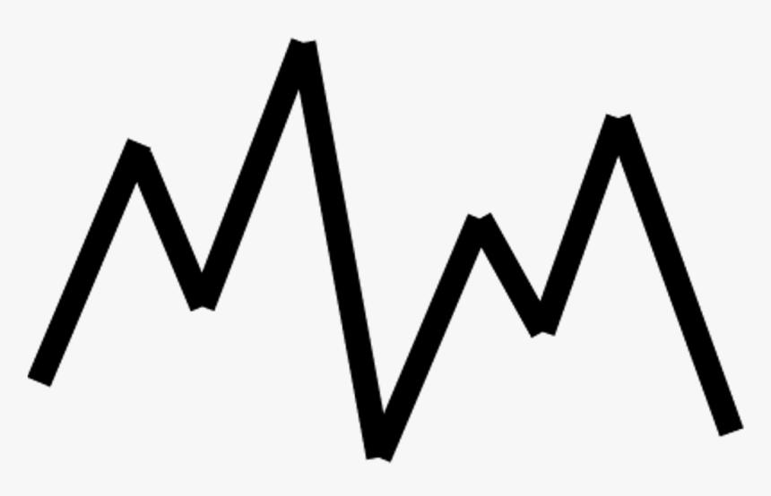

2-Irregular Closed Zigzag Shapes
# Source: AI Source: Provided by: [Data Path: Persons Table -> ID Column: 1, Name_En Column: Motasem Essam] -> From: [ChatGPT] on [7/25/2026]
An Irregular Closed Zigzag Shape returns to its starting point and encloses a region.
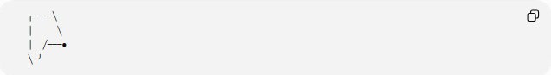
┌────╲
│ ╲
│ ╱───●
╲─╯
When made entirely of straight segments, it can form an irregular polygon.
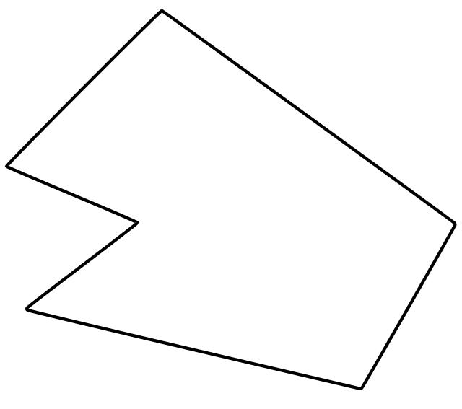
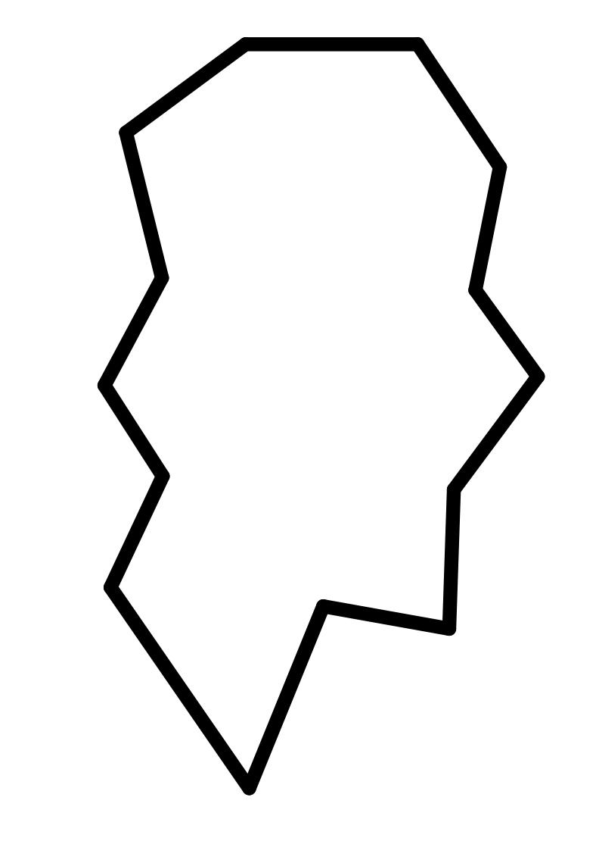
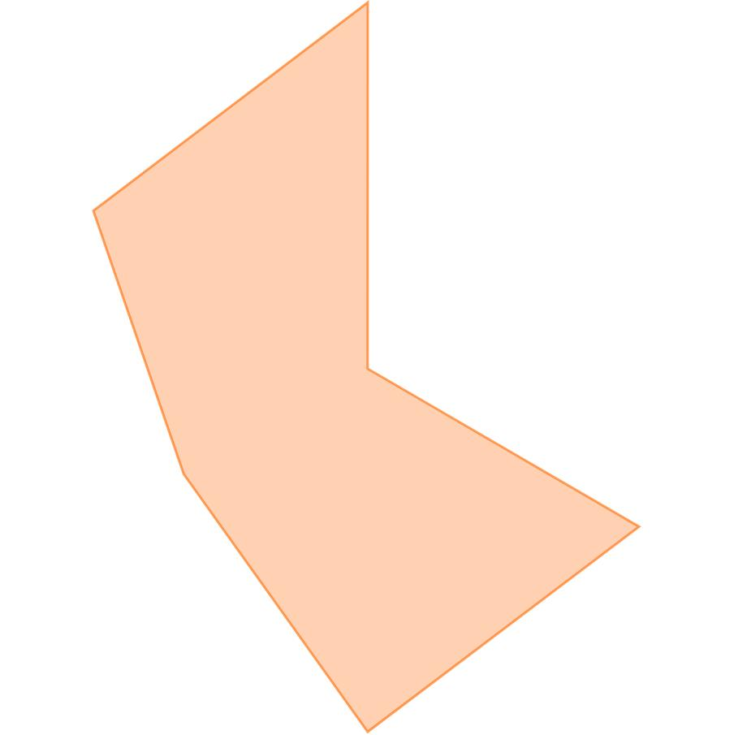
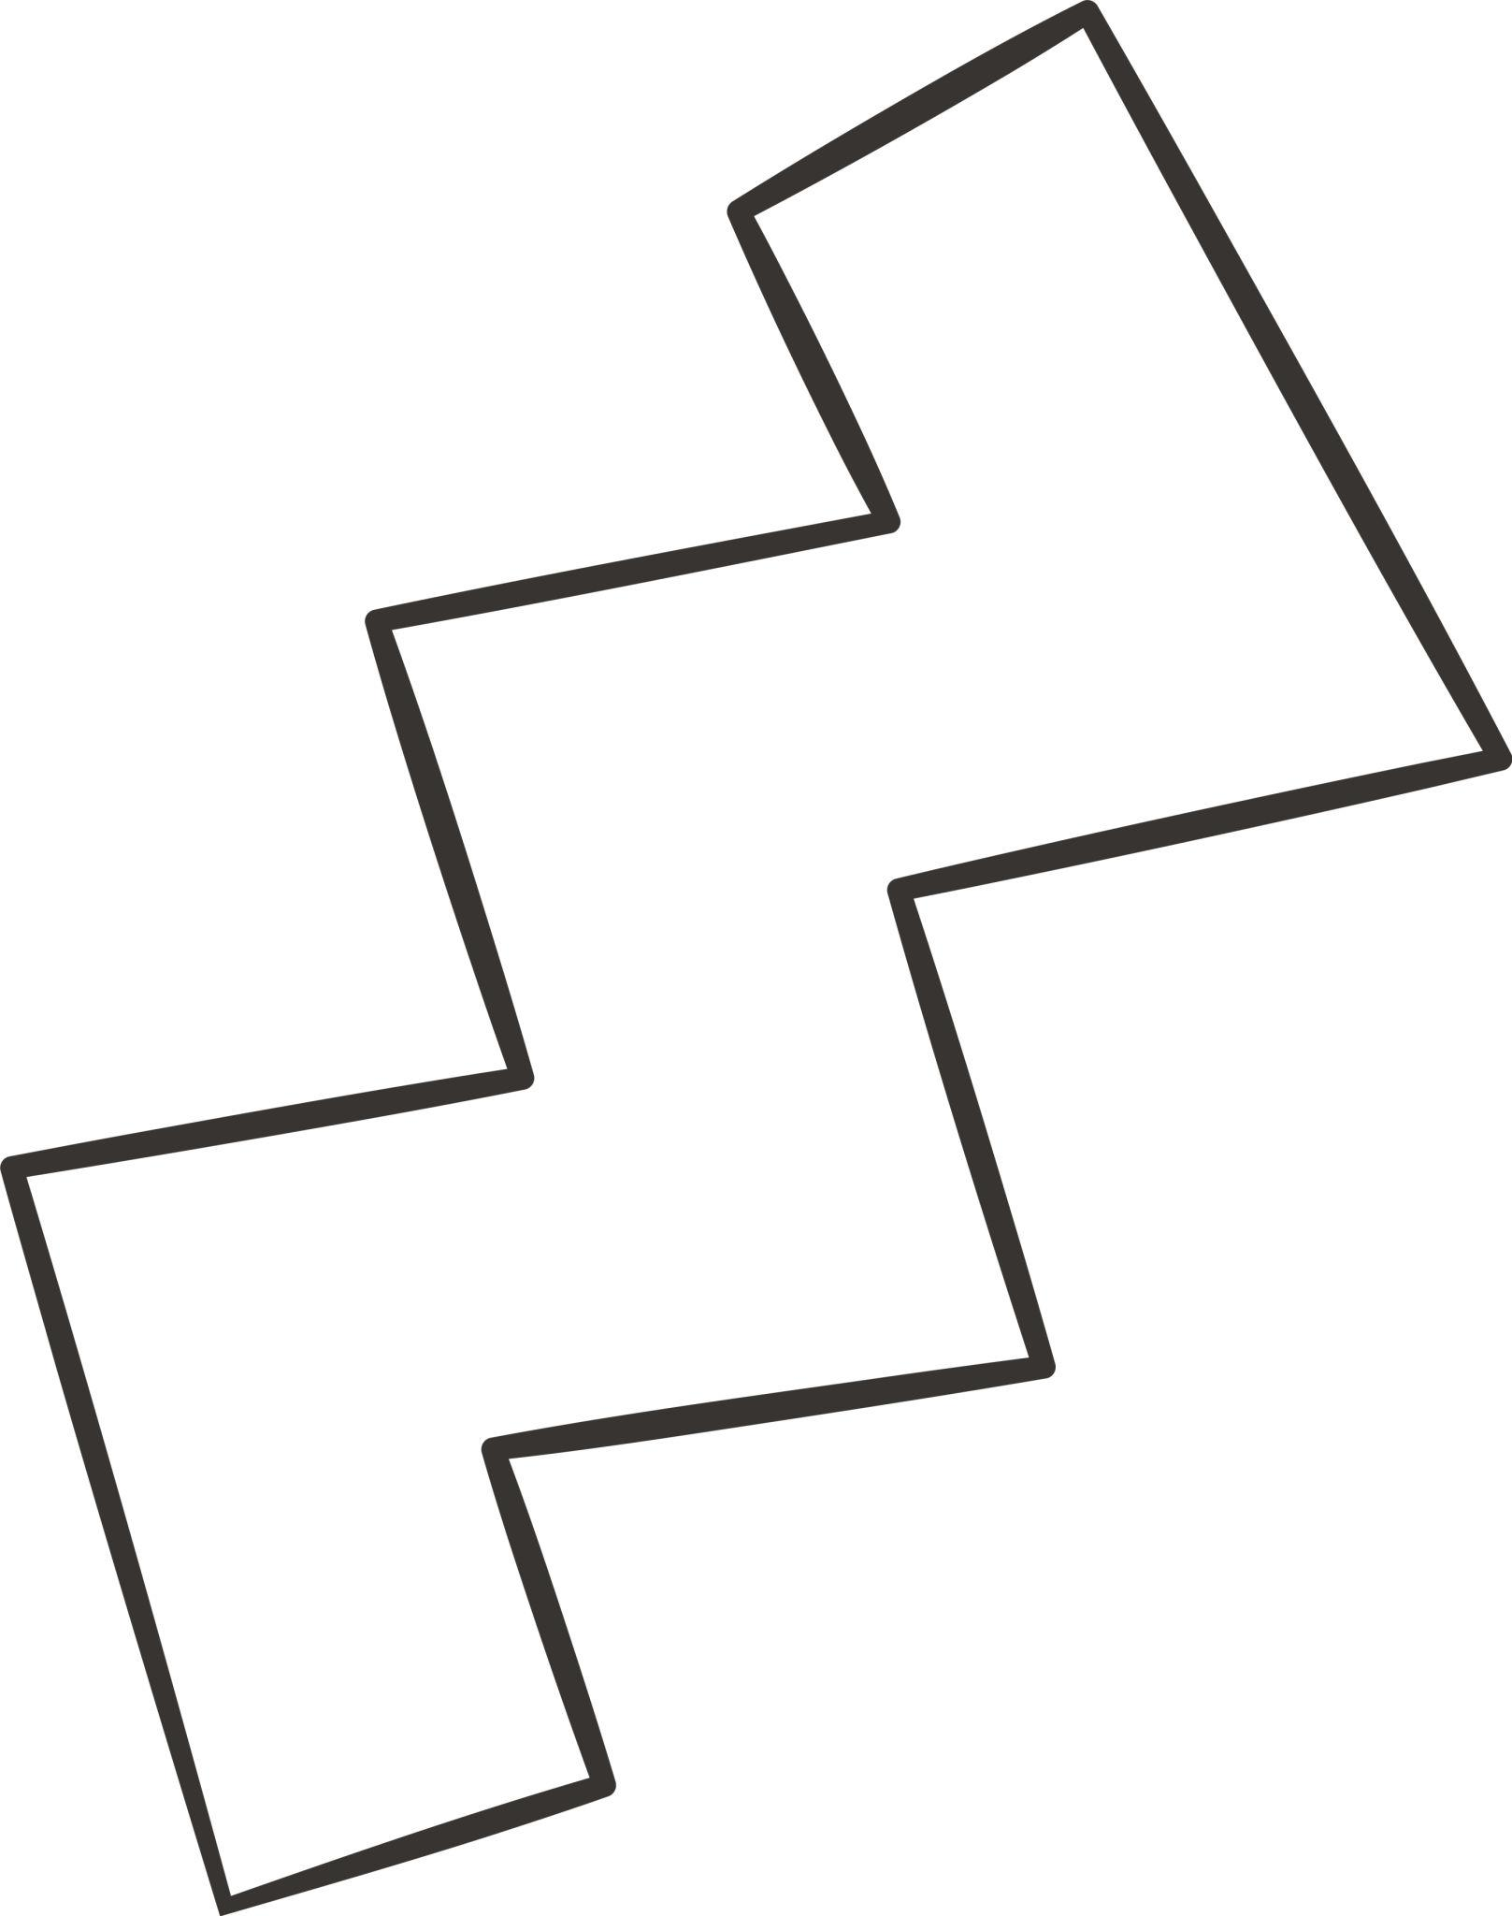

3-Asymmetric Irregular Zigzag Shapes
# Source: AI Source: Provided by: [Data Path: Persons Table -> ID Column: 1, Name_En Column: Motasem Essam] -> From: [ChatGPT] on [7/25/2026]
An Asymmetric Irregular Zigzag Shape has no corresponding symmetry under the transformation being considered.
Its left and right portions, for example, may have completely different arrangements.

4-Unequal-Segment Zigzag Shapes
# Source: AI Source: Provided by: [Data Path: Persons Table -> ID Column: 1, Name_En Column: Motasem Essam] -> From: [ChatGPT] on [7/25/2026]
An Unequal-Segment Zigzag Shape contains segments of different lengths:
$$l_{1}≠l_{2}≠l_{3}$$
For example:
╱╲────╱╲────────╲
The lengths vary significantly.

5-Unequal-Angle Zigzag Shapes
# Source: AI Source: Provided by: [Data Path: Persons Table -> ID Column: 1, Name_En Column: Motasem Essam] -> From: [ChatGPT] on [7/25/2026]
An Unequal-Angle Zigzag Shape has varying turning angles.
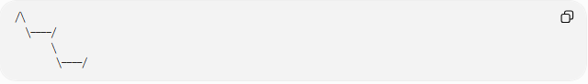
╱╲
╲────╱
╲
╲────╱
The direction changes are not uniform.

6-Mixed Irregular Zigzag Shapes
# Source: AI Source: Provided by: [Data Path: Persons Table -> ID Column: 1, Name_En Column: Motasem Essam] -> From: [ChatGPT] on [7/25/2026]
A Mixed Irregular Zigzag Shape has multiple types of variation at once.
For example:
- different segment lengths,
- different turning angles,
- different zigzag depths,
- asymmetric arrangement.

Mathematical Properties
# Source: AI Source: Provided by: [Data Path: Persons Table -> ID Column: 1, Name_En Column: Motasem Essam] -> From: [ChatGPT] on [7/25/2026]
Number of Segments
If an open zigzag contains $n$vertices, it has:
$$\boxed{n-1}$$
segments.
For a closed zigzag polygon:
$$\boxed{n}$$
segments.
Total Length
If the segment lengths are:
$$l_{1},l_{2},…,l_{n}$$
then the total path length is:
$$\boxed{L=\sum_{i=1}^{n}{l_{i}}}$$
or:
$$\boxed{L=l_{1}+l_{2}+⋯+l_{n}}$$
Closed Irregular Zigzag
If the irregular zigzag is a simple closed polygon with $n$sides, its interior-angle sum is:
$$\boxed{S=\left(n-2\right){180}^{∘}}$$
Its irregularity does not change this formula.

Irregular vs. Regular Zigzag Shapes
# Source: AI Source: Provided by: [Data Path: Persons Table -> ID Column: 1, Name_En Column: Motasem Essam] -> From: [ChatGPT] on [7/25/2026]
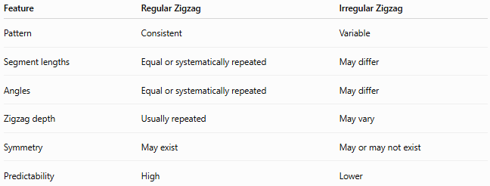
Feature | Regular Zigzag | Irregular Zigzag
Pattern | Consistent | Variable
Segment lengths | Equal or systematically repeated | May differ
Angles | Equal or systematically repeated | May differ
Zigzag depth | Usually repeated | May vary
Symmetry | May exist | May or may not exist
Predictability | High | Lower
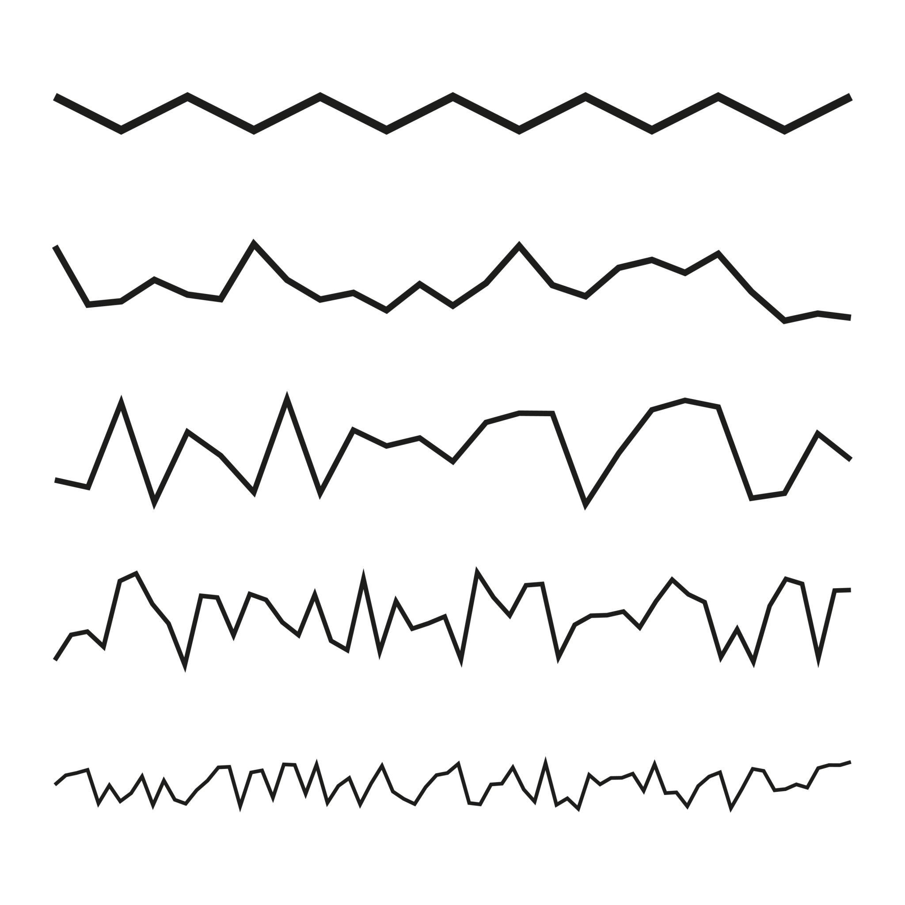
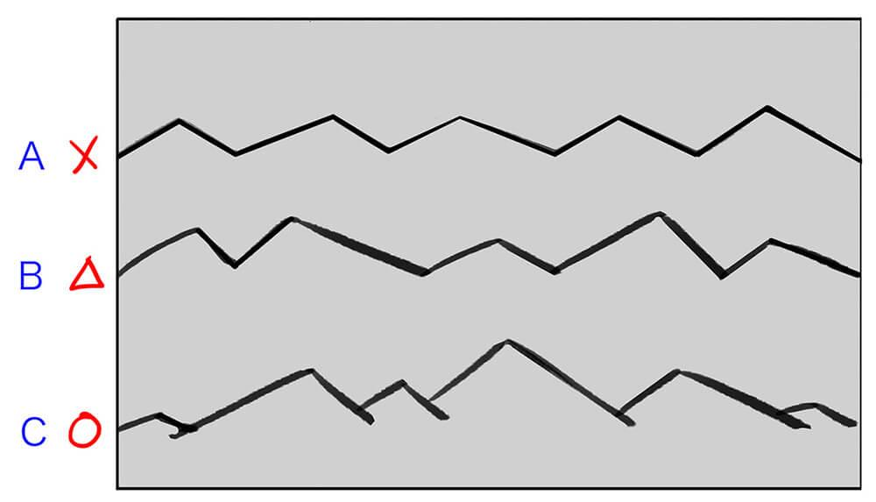
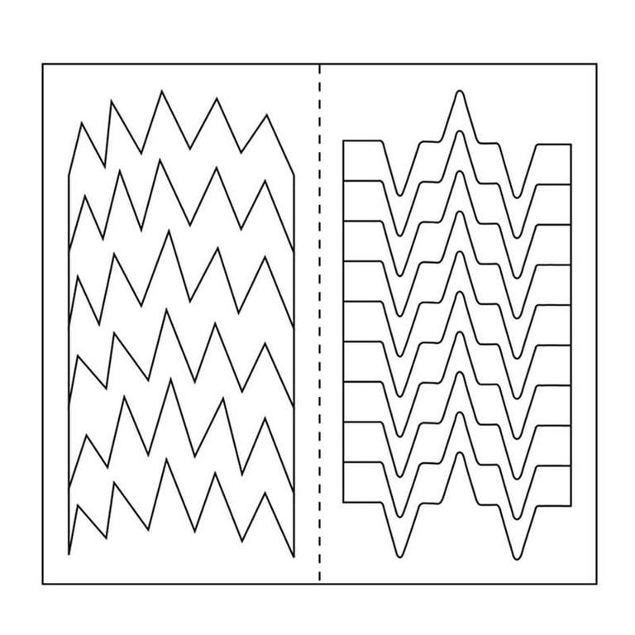

Irregular Zigzag vs. Asymmetric Zigzag
# Source: AI Source: Provided by: [Data Path: Persons Table -> ID Column: 1, Name_En Column: Motasem Essam] -> From: [ChatGPT] on [7/25/2026]
These terms describe different properties.
- Irregular describes a lack of a consistent geometric pattern.
- Asymmetric describes a lack of symmetry.
Therefore, a shape can be:
- irregular and symmetric,
- irregular and asymmetric,
- regular and symmetric,
- or, depending on the chosen definition of regularity, regular and asymmetric.
So:
$$\boxed{\text{Irregularity}≠\text{Asymmetry}}$$

Examples

Example 1 – Irregular Open Zigzag
# Source: AI Source: Provided by: [Data Path: Persons Table -> ID Column: 1, Name_En Column: Motasem Essam] -> From: [ChatGPT] on [7/25/2026]
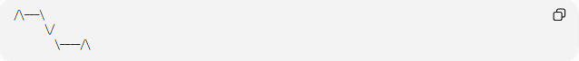2
╱╲───╲
╲╱
╲────╱╲
The path remains open and its segments vary.

Example 2 – Irregular Closed Zigzag
# Source: AI Source: Provided by: [Data Path: Persons Table -> ID Column: 1, Name_En Column: Motasem Essam] -> From: [ChatGPT] on [7/25/2026]
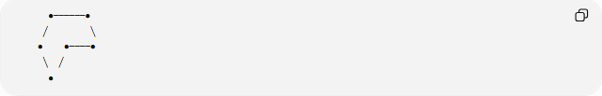
●──────●
╱ ╲
● ●────●
╲ ╱
●
The boundary closes but does not follow a uniform pattern.

Example 3 – Unequal-Segment Zigzag
# Source: AI Source: Provided by: [Data Path: Persons Table -> ID Column: 1, Name_En Column: Motasem Essam] -> From: [ChatGPT] on [7/25/2026]
╱╲──────╱╲──╲
The lengths of the segments are different.

Classification Summary
# Source: AI Source: Provided by: [Data Path: Persons Table -> ID Column: 1, Name_En Column: Motasem Essam] -> From: [ChatGPT] on [7/25/2026]
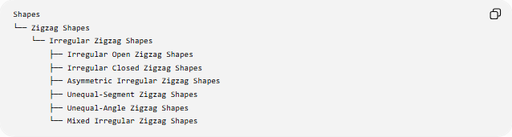
Shapes
└── Zigzag Shapes
└── Irregular Zigzag Shapes
├── Irregular Open Zigzag Shapes
├── Irregular Closed Zigzag Shapes
├── Asymmetric Irregular Zigzag Shapes
├── Unequal-Segment Zigzag Shapes
├── Unequal-Angle Zigzag Shapes
└── Mixed Irregular Zigzag Shapes

Key Points
# Source: AI Source: Provided by: [Data Path: Persons Table -> ID Column: 1, Name_En Column: Motasem Essam] -> From: [ChatGPT] on [7/25/2026]
- An Irregular Zigzag Shape has a non-uniform zigzag pattern.
- Its segment lengths may vary.
- Its turning angles may vary.
- Its zigzag depths may vary.
- It can be open or closed.
- A closed irregular zigzag can form an irregular polygon.
- Irregularity and asymmetry are different concepts.
- The total length is the sum of the individual segment lengths.
- If it forms a simple closed $n$-sided polygon, its interior-angle sum is:
$$\boxed{\left(n-2\right){180}^{∘}}$$

Conclusion
# Source: AI Source: Provided by: [Data Path: Persons Table -> ID Column: 1, Name_En Column: Motasem Essam] -> From: [ChatGPT] on [7/25/2026]
An Irregular Zigzag Shape is a zigzag form whose geometric elements do not follow a uniform repeating pattern. Variations in segment lengths, turning angles, and zigzag depth distinguish it from a regular zigzag. It may be either open or closed and may also be symmetric or asymmetric.

